

**FPTU Event Management**

**Software Design Document**

**Version 1.0**

**Prepared by**

**Nguyễn Thành Trung**

**Phan Minh Nhựt**

**Trịnh Nam Anh**

– Ho Chi Minh, November 2021 –

**Table of Contents**

I. Overview 6

1. Code Packages/Namespaces 6

2. Database Schema 6

II. Code Designs 8

1. Login/Register 8

a. Class Diagram 8

b. Sequence Diagram(s) 8

c. Database queries 9

2. Log out 10

a. Class Diagram 10

b. Sequence Diagram(s) 10

c. Database queries 10

3. View Main Page 11

a. Class Diagram 11

b. Sequence Diagram(s) 11

c. Database queries 12

4. View Events 13

a. Class Diagram 13

b. Sequence Diagram(s) 13

c. Database queries 14

5. View Event’s Detail 15

a. Class Diagram 15

b. Sequence Diagram(s) 15

c. Database queries 16

6. Follow/Unfollow Event 17

a. Class Diagram 17

b. Sequence Diagram(s) 17

c. Database queries 18

7. Join Event/Unjoin Event 19

a. Class Diagram 19

b. Sequence Diagram(s) 19

c. Database queries 20

8. View Followed Events 21

a. Class Diagram 21

b. Sequence Diagram(s) 21

c. Database queries 22

9. View Posts 23

a. Class Diagram 23

b. Sequence Diagram(s) 23

c. Database queries 24

10. View Post’s Detail 25

a. Class Diagram 25

b. Sequence Diagram(s) 25

c. Database queries 26

11. Setting Profile 27

a. Class Diagram 27

b. Sequence Diagram(s) 27

c. Database queries 28

12. View User’s Accounts 29

a. Class Diagram 29

b. Sequence Diagram(s) 29

c. Database queries 29

13. Update User’s Accounts 30

a. Class Diagram 30

b. Sequence Diagram(s) 30

c. Database queries 30

14. View Locations 31

a. Class Diagram 31

b. Sequence Diagram(s) 31

c. Database queries 31

15. Add New Location 32

a. Class Diagram 32

b. Sequence Diagram(s) 32

c. Database queries 32

16. Update Location 33

a. Class Diagram 33

b. Sequence Diagram(s) 33

c. Database queries 33

17. Remove Location 34

a. Class Diagram 34

b. Sequence Diagram(s) 34

c. Database queries 34

18. Create Event 35

a. Class Diagram 35

b. Sequence Diagram(s) 35

c. Database queries 35

19. View Created Event 36

a. Class Diagram 36

b. Sequence Diagram(s) 36

c. Database queries 37

20. Edit Event 38

a. Class Diagram 38

b. Sequence Diagram(s) 38

c. Database queries 38

21. Create Post 39

a. Class Diagram 39

b. Sequence Diagram(s) 39

c. Database queries 39

22. View Created Post 40

a. Class Diagram 40

b. Sequence Diagram(s) 40

c. Database queries 41

23. Edit Post 42

a. Class Diagram 42

b. Sequence Diagram(s) 42

c. Database queries 42

24. Upload File 43

a. Class Diagram 43

b. Sequence Diagram(s) 43

c. Database queries 43

# I. Overview

## 1. Code Packages/Namespaces

***Package descriptions & package class naming conventions***

|  |  |  |
| --- | --- | --- |
| **No** | **Package** | **Description** |
| *01* | *src.java.Controller* | *Containing servlets* |
| *02* | *src.java.DAO* | *Containing underlying tools that help with the Data Access Object processes with database* |
| *03* | *src.java.DTO* | *Containing underlying tools that help with the Data Transfer Object.* |
| *04* | *src.java.Extension* | *Containing underlying tools that help with data formatting and common action supporting.* |
| *05* | *src.java.GoogleAPI* | *Containing GoogleAPI which is used for authentication features.* |
| *05* | *src.java.Utils* | *Containing underlying tools that help with connection or disconnect to the database.* |
| *07* | *web.CSS* | *Containing Cascading Style Sheets files for client’s view.* |
| *06* | *web.JS* | *Containing JavaScript files for client’s view.* |
| *08* | *web.about* | *Containing prepared data for specified client’s page.* |
| *09* | *web.images* | *Containing title images for events or posts.* |
| *09* | *web.img* | *Containing default images for client’s view.* |

## 2. Database Schema

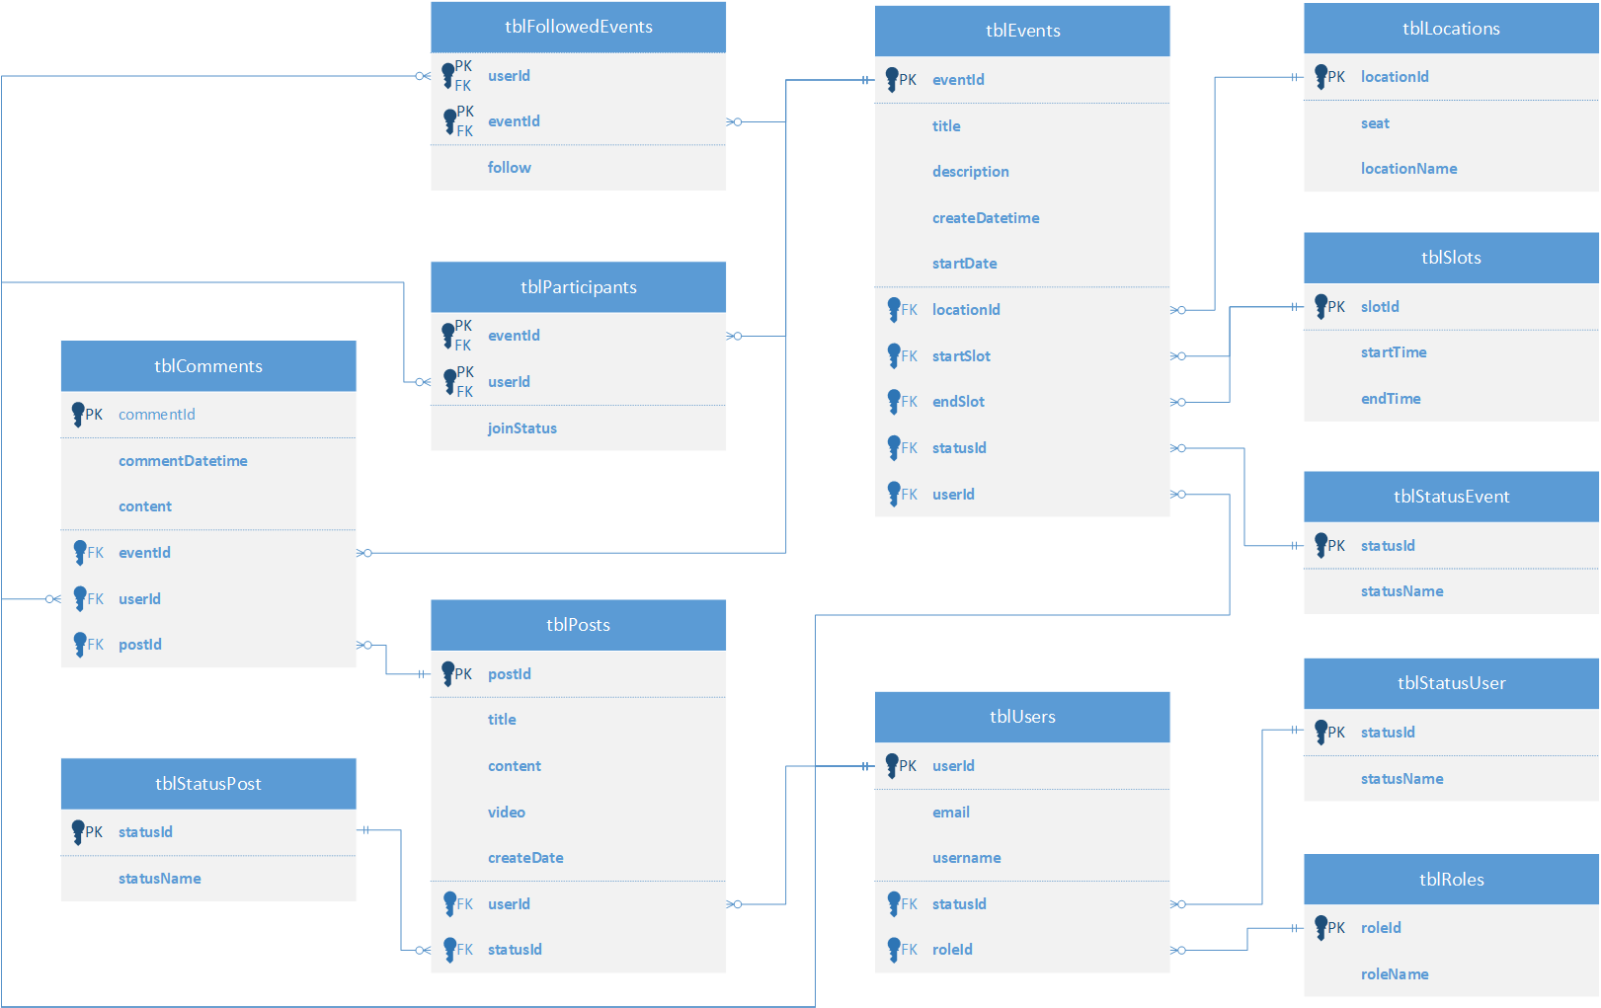

***Table descriptions & package class naming conventions are as below***

|  |  |  |
| --- | --- | --- |
| **No** | **Table** | **Description** |
| *01* | *tblRoles* | *Specify role for each account.*  *- Primary key: roleId* |
| *02* | *tblStatusUser* | *Specify status (permit or unpermit) for each account.*  *- Primary key: statusId* |
| *03* | *tblUsers* | *Specify user’s identification for each account*  *- Primary key: userId*  *- Foreign keys: statusId, roleId* |
| *04* | *tblSlots* | *Specify start time and end time for each slot (6 slots per day).*  *- Primary key: slotId* |
| *05* | *tblLocations* | *Specify location for hosted events*  *- Primary key: locationId* |
| *06* | *tblEvents* | *Specify event’s details for each existed event.*  *- Primary key: eventId*  *- Foreign keys: locationId, startSlot, endSlot, statusId, userId* |
| *07* | *tblFollowedEvents* | *Specify events which are followed or used to be followed by users.*  *- Primary key: userId, eventId*  *- Foreign keys: userId, eventId* |
| *08* | *tblParticipants* | *Specify users who join in or were in charged of joining in specified event.*  *- Primary key: userId, eventId*  *- Foreign keys: userId, eventId* |
| *09* | *tblStatusPost* | *Specify status for each existed post.*  *- Primary key: statusId* |
| *10* | *tblPosts* | *Specify post’s details*  *- Primary key: postId*  *- Foreign keys: userId , statusId* |
| *11* | *tblComments* | *Specify comments in specified events or posts.*  *- Primary key: userId*  *- Foreign keys: eventide, userId, postId* |

# II. Code Designs

## 1. Login/Register

### a. Class Diagram

### b. Sequence Diagram(s)

Figure 1 - Login

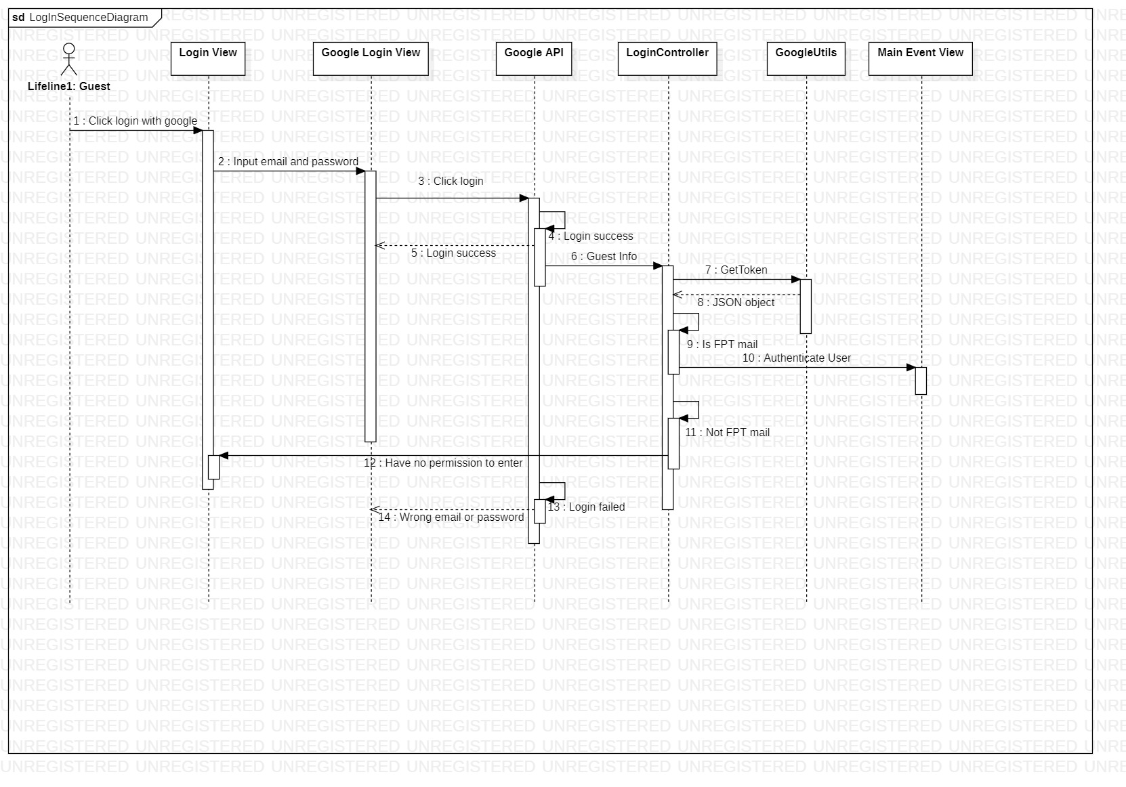

### c. Database queries

- Get user’s data from database:

userID = user’s ID from user’s data at Figure 1 step 10.

*SELECT username, r.roleName, s.statusName*

*FROM tblUsers u, tblStatusUser s, tblRoles r*

*WHERE u.userId =* userID *AND u.statusId = s.statusId AND u.roleId = r.roleId*

## 2. Log out

### a. Class Diagram

### b. Sequence Diagram(s)

Figure 1 - Logout Diagram

Description automatically generated

### c. Database queries

*- No query for this feature.*

## 3. View Main Page

### a. Class Diagram

### b. Sequence Diagram(s)

Figure 3 – View main page

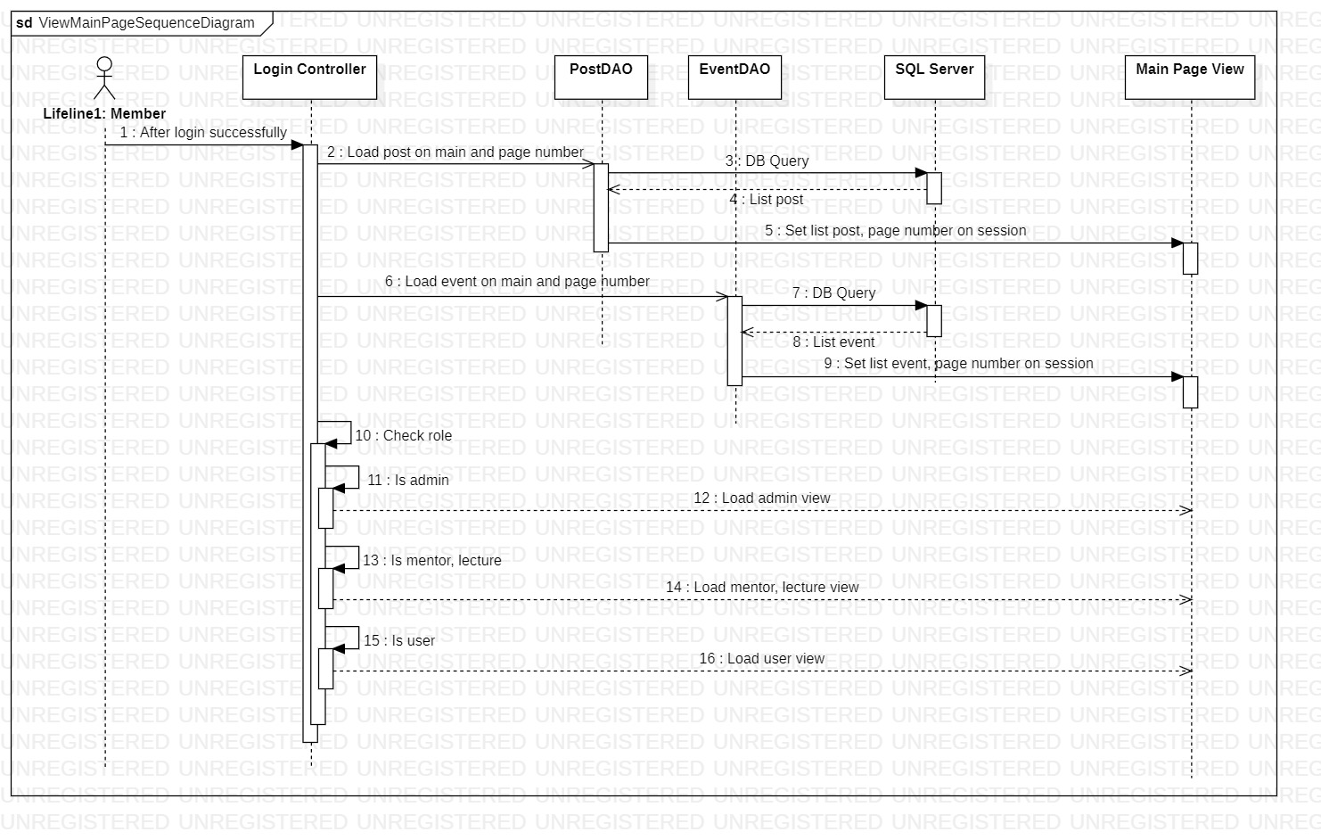

### c. Database queries

- Get events by page

Search = %%

Index = 1

PageSize = 6

*WITH tblEventPage AS*

*(SELECT (ROW_NUMBER() over (order by startDate) ) AS RowNum,*

*eventId, userId, title, description, locationId, createDatetime, startDate, startSlot, endSlot, s.statusName AS status*

*FROM tblEvents e, tblStatusEvent s*

*WHERE* title like search AND *e.statusId = s.statusId)*

*SELECT eventId, userId, title, description, locationId, createDatetime, startDate, startSlot, endSlot, status*

*FROM tblEventPage*

*WHERE RowNum BETWEEN* Index *\** PageSize *- (*PageSize *-1) AND* Index *\** PageSize

- Update events’ status each time query event’s list

UPDATE tblEvents

SET statusId = (SELECT statusId FROM tblStatusEvent WHERE statusName = ?)

WHERE eventId = ?

(Note: parameters’ values is passed from “Get event by page”)

- Get posts by page

Search = %%

Index = 1

PageSize = 3

WITH tblPostPage AS

(SELECT (ROW_NUMBER() over (order by createDate) ) AS RowNum,

postId, userId, title, content, video, createDate,s.statusName AS status

FROM tblPosts e, tblStatusPost s

WHERE title like Search AND e.statusId = s.statusId)

SELECT postId, userId, title, content, video, createDate, status

FROM tblPostPage

WHERE RowNum Index *\** PageSize *- (*PageSize *-1) AND* Index *\** PageSize

## 4. View Events

### a. Class Diagram

### b. Sequence Diagram(s)

Figure 4 – View events by page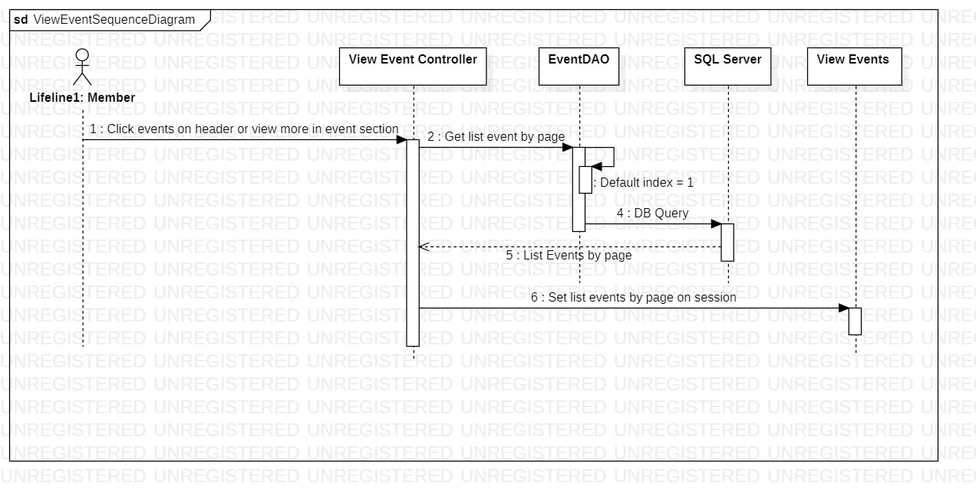

### c. Database queries

userID = User’s id stored in HttpSession

- Get events by page

Search = %%

Index = selected index page from Figure 4

PageSize = 6

*WITH tblEventPage AS*

*(SELECT (ROW_NUMBER() over (order by startDate) ) AS RowNum,*

*eventId, userId, title, description, locationId, createDatetime, startDate, startSlot, endSlot, s.statusName AS status*

*FROM tblEvents e, tblStatusEvent s*

*WHERE* title like search AND *e.statusId = s.statusId)*

*SELECT eventId, userId, title, description, locationId, createDatetime, startDate, startSlot, endSlot, status*

*FROM tblEventPage*

*WHERE RowNum BETWEEN* Index *\** PageSize *- (*PageSize *-1) AND* Index *\** PageSize

- Update events’ status each time query event’s list

UPDATE tblEvents

SET statusId = (SELECT statusId FROM tblStatusEvent WHERE statusName = ?)

WHERE eventId = ?

(Note: parameters’ values is passed from “Get event by page”)

- Get count of events for pagination

*SELECT COUNT(eventId) as count*

*FROM tblEvents*

## 5. View Event’s Detail

### a. Class Diagram

### b. Sequence Diagram(s)

Figure 5 – View selected event’s details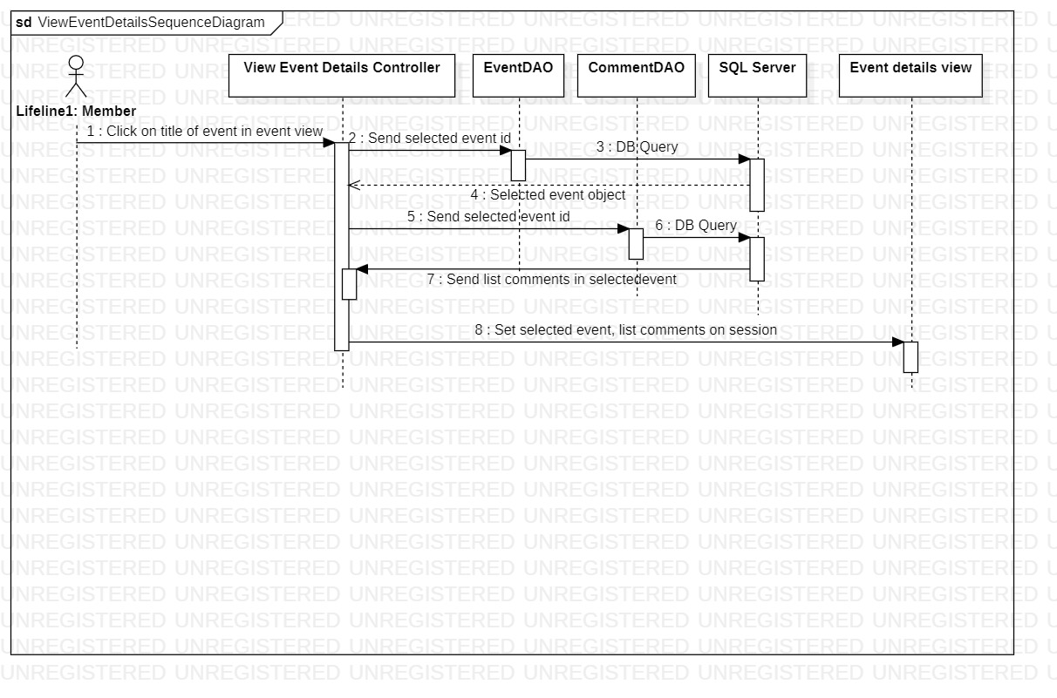

### c. Database queries

eventID = Event’s id passed from selected event in events page

userID = User’s id stored in HttpSession

- Get selected event’s details

SELECT userId, title, description, locationId, createDatetime, startDate, startSlot, endSlot, s.statusName

FROM tblEvents e, tblStatusEvent s

WHERE eventId = eventID AND s.statusId = e.statusId

- Get comment count in selected event

SELECT userId,commentDatetime, content FROM tblComments WHERE eventId = eventID

- Get comments to load to view

Index = 1 and increment for each “View more comments” click.

PageSize = 6

WITH tblCommentPage AS

(SELECT (ROW_NUMBER() over (order by commentDatetime desc) ) AS RowNum,

content, commentDatetime, userId

FROM tblComments

WHERE eventId= eventID)

SELECT content, commentDatetime, userId

FROM tblCommentPage

WHERE RowNum BETWEEN Index * PageSize -(PageSize -1) AND Index * PageSize

- Get follow status

SELECT follow

FROM tblFollowedEvent

WHERE userId = userID AND eventId = eventID

- Get join status

SELECT joinStatus

FROM tblParticipants

WHERE userId = userID AND eventId = eventID

## 6. Follow/Unfollow Event

### a. Class Diagram

### b. Sequence Diagram(s)

Figure 6 – Follow or unfollow selected event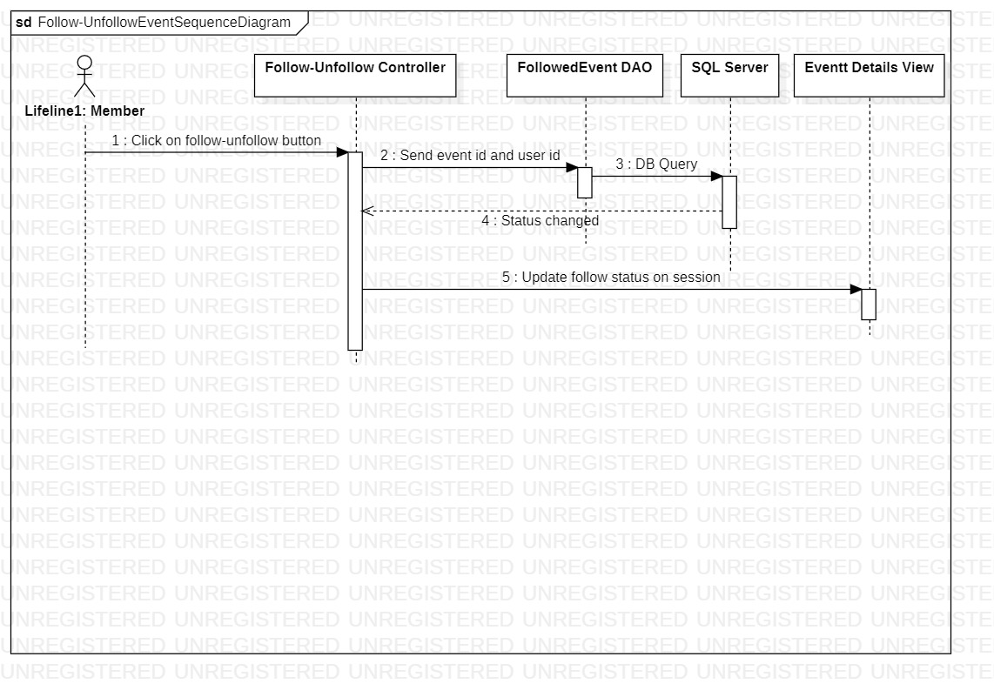

### c. Database queries

eventID = Event’s id passed from selected event in events page

userID = User’s id stored in HttpSession

- Follow for the first time

INSERT INTO tblFollowedEvent (userId, eventId, follow)

VALUES (userID, eventID, 1)

- Follow/Unfollow (Change follow status)

Follow = 0 if previous value was 1 or

1 if previous value was 0

UPDATE tblFollowedEvent

SET follow = Follow

WHERE userId= userID AND eventId = eventID

- Get follow status

SELECT follow

FROM tblFollowedEvent

WHERE userId = userID AND eventId = eventID

- Get join status

SELECT joinStatus

FROM tblParticipants

WHERE userId = userID AND eventId = eventID

## 7. Join Event/Unjoin Event

### a. Class Diagram

### b. Sequence Diagram(s)

Figure 7 – Join or unjoin an event Diagram

Description automatically generated

### c. Database queries

eventID = Event’s id passed from selected event in events page

userID = User’s id stored in HttpSession

- Get number of participants of the event

SELECT COUNT(userId)

FROM tblParticipants

WHERE eventId = eventID AND userId != userID AND joinStatus = 1

- Get join status

SELECT joinStatus

FROM tblParticipants

WHERE userId = userID AND eventId = eventID

- Join in for the first time in selected event

INSERT INTO tblParticipants(eventId, userId, joinStatus)

VALUES (eventID , userID, 1)

- Join/Unjoin (Change join status)

Join = 0 if previous value was 1 or

1 if previous value was 0

UPDATE tblParticipants

SET joinStatus= Join

WHERE userId= userID AND eventId = eventID

- Get follow status

SELECT follow

FROM tblFollowedEvent

WHERE userId = userID AND eventId = eventID

## 8. View Followed Events

### a. Class Diagram

### b. Sequence Diagram(s)

Figure 8 – View followed events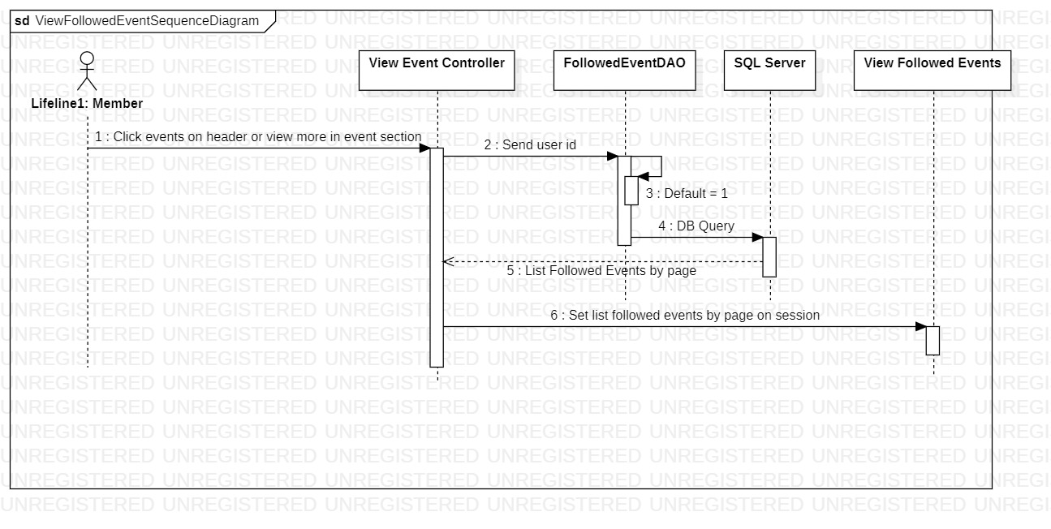

### c. Database queries

userID = User’s id stored in HttpSession

- Get count of events created by user for pagination

*SELECT COUNT(userId) as count*

*FROM tblFollowedEvent*

*WHERE follow = 1 AND userId =* userID

- Get events by page

Search = %%

Index = selected index page from Figure 8

PageSize = 6

*WITH tblEventPage AS*

*(SELECT (ROW_NUMBER() over (order by startDate) ) AS RowNum, e.eventId, e.userId, title, description, locationId, createDatetime, startDate, startSlot, endSlot, s.statusName AS status*

*FROM tblEvents e, tblStatusEvent s, tblFollowedEvent f*

*WHERE title like* Search *AND e.statusId = s.statusId AND f.userId = ? AND f.eventId = e.eventId AND f.follow = 1)*

*SELECT eventId, userId, title, description, locationId, createDatetime, startDate, startSlot, endSlot, status*

*FROM tblEventPage*

*WHERE RowNum BETWEEN* Index *\** PageSize *- (*PageSize *-1) AND* Index *\** PageSize

- Update events’ status each time query event’s list

UPDATE tblEvents

SET statusId = (SELECT statusId FROM tblStatusEvent WHERE statusName = ?)

WHERE eventId = ?

(Note: parameters’ values is passed from “Get event by page”)

## 9. View Posts

### a. Class Diagram

### b. Sequence Diagram(s)

Figure 9 – View posts by page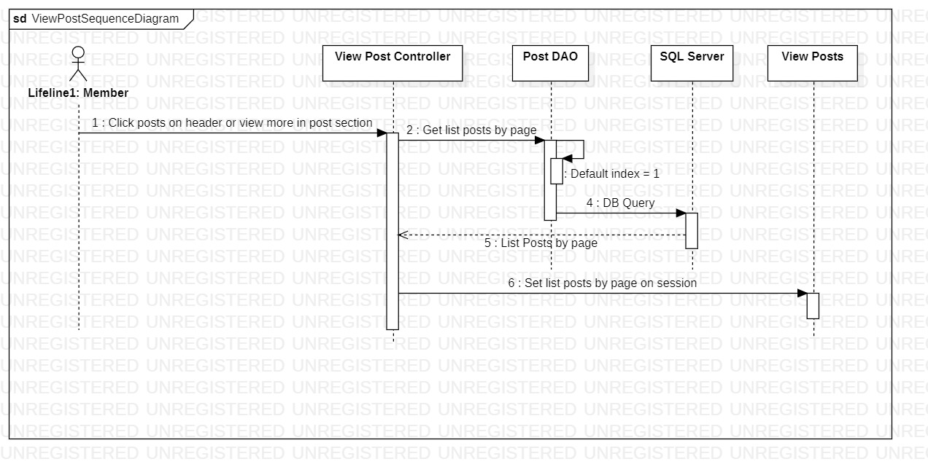

### c. Database queries

userID = User’s id stored in HttpSession

- Get events by page

Search = %%

Index = selected index page from Figure 9

PageSize = 6

*WITH tblPostPage AS*

*(SELECT (ROW_NUMBER() over (order by createDate) ) AS RowNum, postId, userId, title, content, video, createDate,s.statusName AS status*

*FROM tblPosts e, tblStatusPost s*

*WHERE title like Search AND e.statusId = s.statusId*

*SELECT postId, userId, title, content, video, createDate, status*

*FROM tblPostPage*

*WHERE RowNum BETWEEN* Index *\** PageSize *- (*PageSize *-1) AND* Index *\** PageSize

- Get count of posts for pagination

*SELECT COUNT(postId) as count*

*FROM tblPosts*

## 10. View Post’s Detail

### a. Class Diagram

### b. Sequence Diagram(s)

Figure 10 – View selected post’s details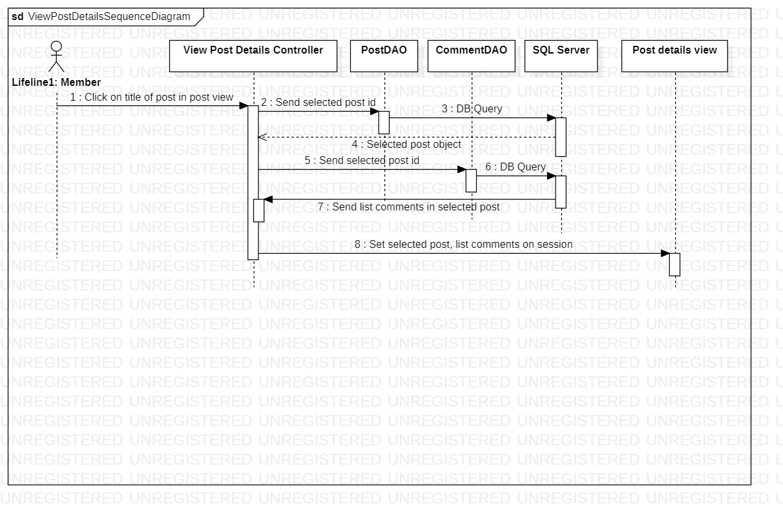

### c. Database queries

postID = Post’s id passed from selected post in posts page

userID = User’s id stored in HttpSession

- Get selected post’s details

SELECT userId, title, content, video, createDate, s.statusName

FROM tblPosts e, tblStatusPost s"

WHERE e.postId= postID AND e.statusId = s.statusId

- Get comment count in selected post

SELECT userId, commentDatetime, content FROM tblComments WHERE postId = postID

- Get comments to load to view

Index = 1 and increment for each “View more comments” click.

PageSize = 6

WITH tblCommentPage AS

(SELECT (ROW_NUMBER() over (order by commentDatetime desc) ) AS RowNum,

content, commentDatetime, userId

FROM tblComments

WHERE eventId= eventID)

SELECT content, commentDatetime, userId

FROM tblCommentPage

WHERE RowNum BETWEEN Index * PageSize -(PageSize -1) AND Index * PageSize

## 11. Setting Profile

### a. Class Diagram

### b. Sequence Diagram(s)

Figure 11 – Setting your profile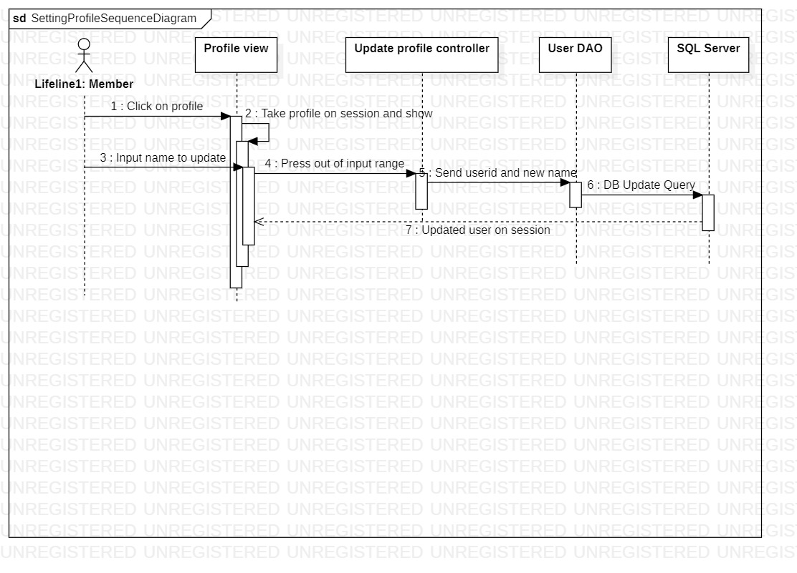

### c. Database queries

userID = User’s id stored in HttpSession

username = User’s new name from Figure 11

- Update profile (username only)

UPDATE tblUsers

SET username = username

WHERE userId = userID

## 12. View User’s Accounts

### a. Class Diagram

### b. Sequence Diagram(s)

Figure 12 – View user accounts list (Administrator)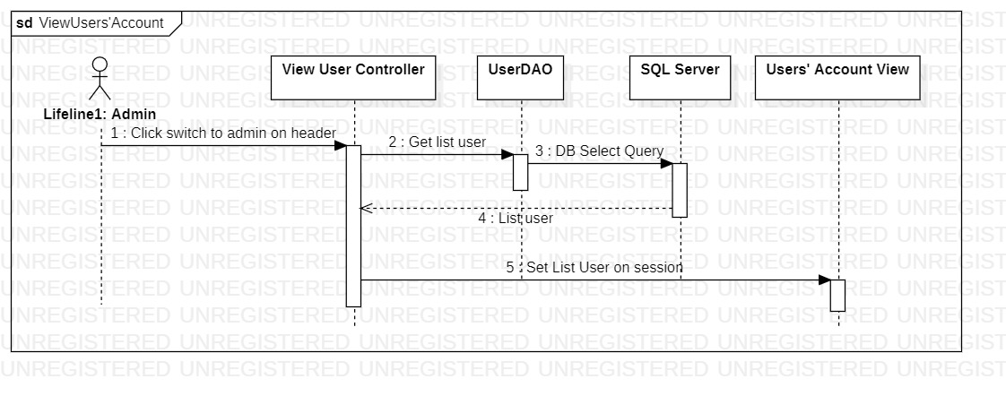

### c. Database queries

- Get list of user accounts

SELECT userId, email, username, s.statusName, r.roleName

FROM tblUsers u, tblStatusUser s, tblRoles r

WHERE u.statusId = s.statusId AND u.roleId = r.roleId

## 13. Update User’s Accounts

### a. Class Diagram

### b. Sequence Diagram(s)

Figure 13 – Update edited user account (Administrator)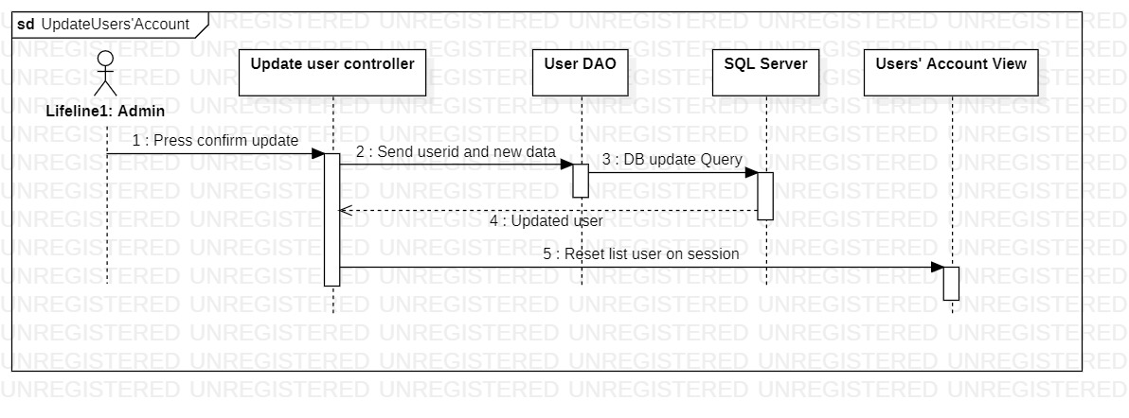

### c. Database queries

userID = User’s id retrieved from Figure 13

roleName = User’s role retrieved from Figure 13

- Update edited account to the database

UPDATE tblUsers

SET roleId = (SELECT roleId FROM tblRoles WHERE roleName = roleName)

WHERE userId = userID

or Change account’s status (ban/unban)

UPDATE tblUsers

SET statusId = (SELECT statusId FROM tblStatusUser WHERE statusName = (1))

WHERE userId = userID

(1) is “Deactive” if statusName is “Active” and vise versa

- Get list of user accounts to the view

SELECT userId, email, username, s.statusName, r.roleName

FROM tblUsers u, tblStatusUser s, tblRoles r

WHERE u.statusId = s.statusId AND u.roleId = r.roleId

## 14. View Locations

### a. Class Diagram

### b. Sequence Diagram(s)

Figure 14 – View locations list (Administrator)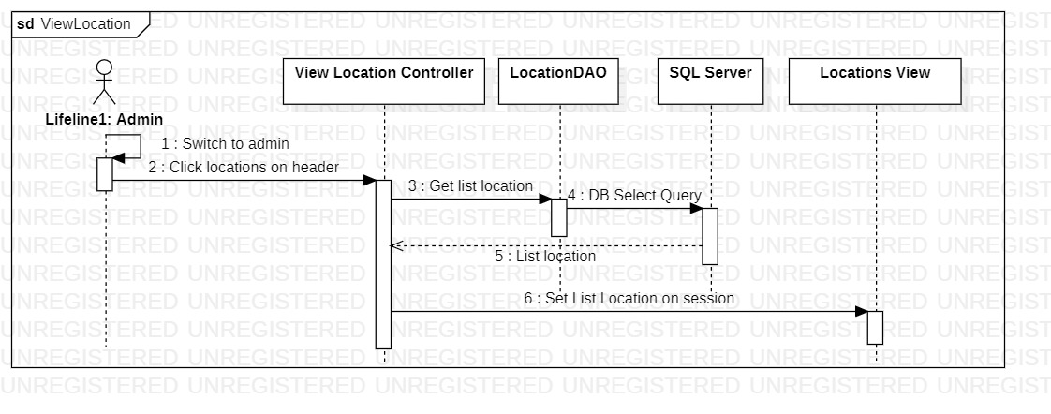

### c. Database queries

- Get count of locations for pagination

SELECT COUNT(locationId) as amount

FROM tblLocations

- Get locations by page

Search = %%

Index = selected index page from Figure 14

PageSize = 10

*WITH tblLocationPage AS*

*(SELECT (ROW_NUMBER() over (order by locationName) ) AS RowNum,*

*locationId, seat, locationName*

*FROM tblLocations*

*WHERE locationName like* Search*)*

*SELECT locationId, seat, locationName \n"*

*FROM tblLocationPage*

*WHERE RowNum BETWEEN* Index *\** PageSize *- (*PageSize *-1) AND* Index *\** PageSize

## 15. Add New Location

### a. Class Diagram

### b. Sequence Diagram(s)

Figure 15 – Add new location (Administrator)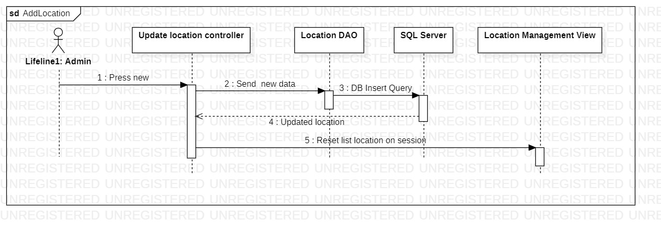

### c. Database queries

locationName = inputted locationName from Figure 16

seat = inputted seat from Figure 16

- Add inserted location into database

INSERT INTO tblLocations (locationName, seat)

VALUES (locationName, seat)

## 16. Update Location

### a. Class Diagram

### b. Sequence Diagram(s)

Figure 16 – Update edited location (Administrator)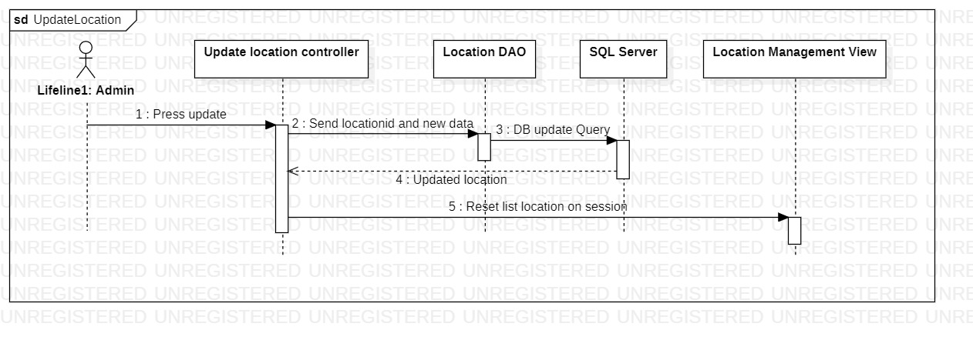

### c. Database queries

locationId = changed location’s id from Figure 16

locationName = inputted locationName from Figure 16

seat = inputted seat from Figure 16

- Update location’s data

UPDATE tblLocations

SET locationName = locationName, seat = seat

WHERE locationId = locationId

## 17. Remove Location

### a. Class Diagram

### b. Sequence Diagram(s)

Figure 17 – Remove selected location (Administrator)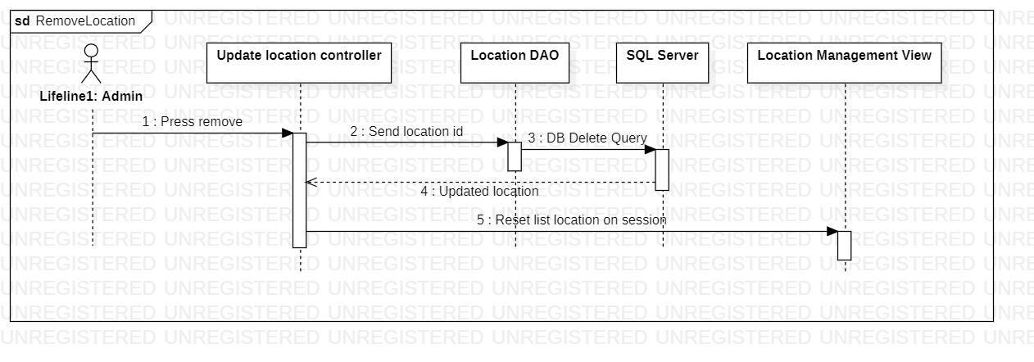

### c. Database queries

locationId = selected location’s id from Figure 18

- Remove selected location

DELETE FROM tblLocations

WHERE locationId = locationId

## 18. Create Event

### a. Class Diagram

### b. Sequence Diagram(s)

Figure 18 – Create new event (Event Manager)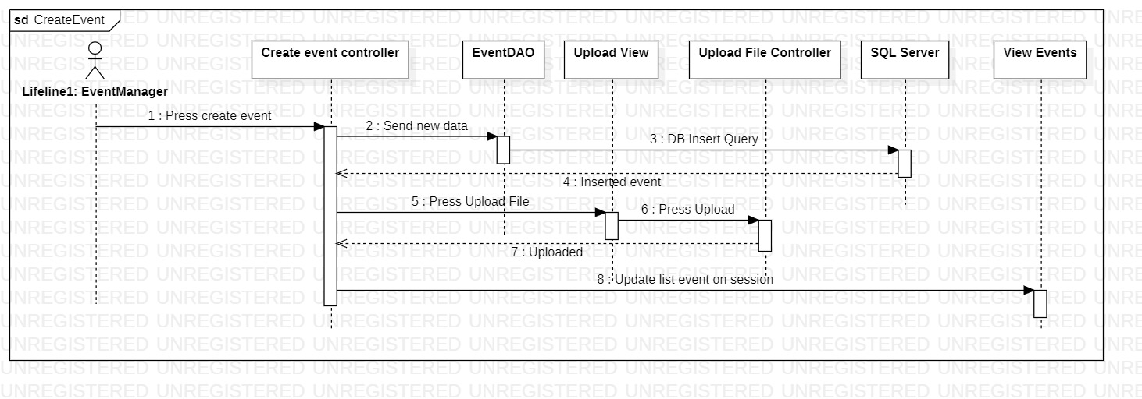

### c. Database queries

- Insert new event into database

INSERT INTO tblEvents

(userId, title, description, locationId, createDatetime, startDate, startSlot, endSlot, statusId)

VALUES (?,?,?,?,?,?,?,?, (SELECT statusId FROM tblStatusEvent WHERE statusName = ?))

## 19. View Created Event

### a. Class Diagram

### b. Sequence Diagram(s)

Figure 19 – View your created events by page (Event Manager)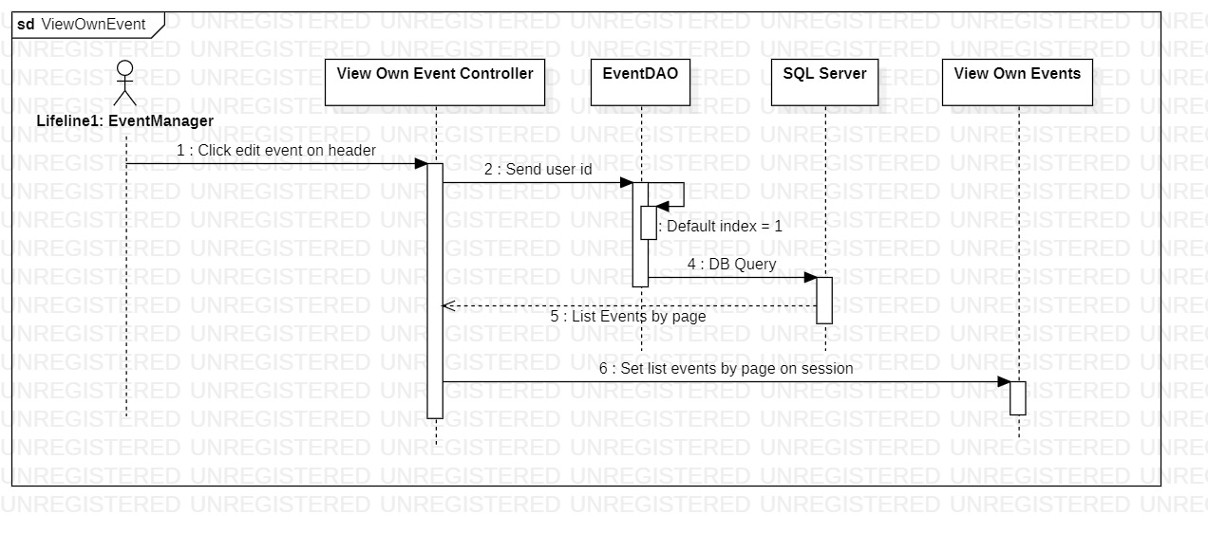

### c. Database queries

userID = User’s id stored in HttpSession

- Get owned events by page

Search = %%

Index = selected index page from Figure 4

PageSize = 6

*WITH tblEventPage AS*

*(SELECT (ROW_NUMBER() over (order by startDate) ) AS RowNum,*

*eventId, userId, title, description, locationId, createDatetime, startDate, startSlot, endSlot, s.statusName AS status*

*FROM tblEvents e, tblStatusEvent s*

*WHERE userId =* userID *AND title like* Search *AND e.statusId = s.statusId)*

*SELECT eventId, userId, title, description, locationId, createDatetime, startDate, startSlot, endSlot, status*

*FROM tblEventPage WHERE RowNum BETWEEN* Index *\** PageSize *- (*PageSize *-1) AND* Index *\** PageSize

- Get count of owned events for pagination

*SELECT COUNT(eventId) as count*

*FROM tblEvents*

*WHERE userId =* userID

## 20. Edit Event

### a. Class Diagram

### b. Sequence Diagram(s)

Figure 20 – Update edited event (Event Manager)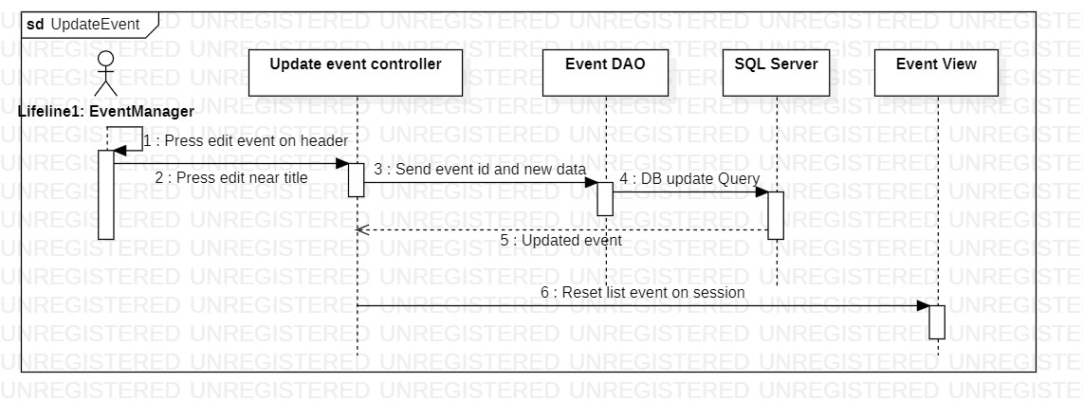

### c. Database queries

eventId = changed event’s id

- Update selected event’s changes to database

UPDATE tblEvents

SET title= ?, description= ?, locationId= ?, startDate= ?, startSlot= ?, endSlot= ?,

statusId = (SELECT statusId FROM tblStatusEvent WHERE statusName = ?)

WHERE eventId= eventId

## 21. Create Post

### a. Class Diagram

### b. Sequence Diagram(s)

Figure 21 – Create new post (Mentor/Lecturer)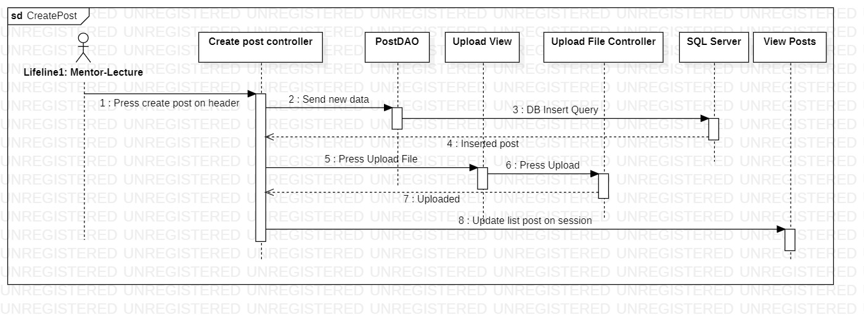

### c. Database queries

- Insert new post into database

INSERT INTO tblPosts (userId, title, content, video, createDate, statusId)

VALUES (?, ?, ?, ?, ?, (SELECT statusId FROM tblStatusPost WHERE statusName = ?))

## 22. View Created Post

### a. Class Diagram

### b. Sequence Diagram(s)

Figure 22 – View your created posts by page (Mentor/Lecturer)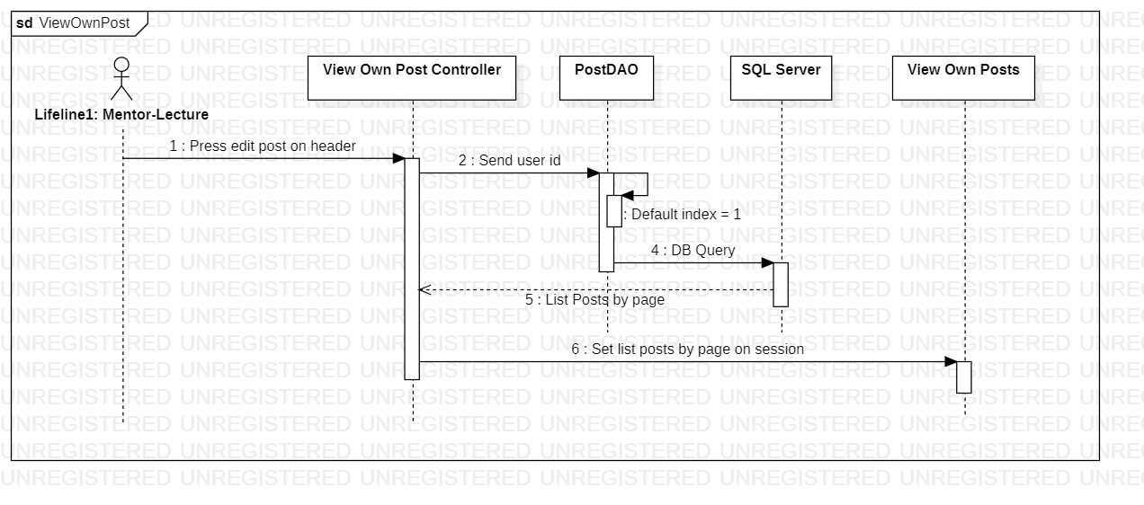

### c. Database queries

userID = User’s id stored in HttpSession

- Get events by page

Search = %%

Index = selected index page from Figure 22

PageSize = 6

*WITH tblPostPage AS*

*(SELECT (ROW_NUMBER() over (order by createDate) ) AS RowNum,*

*userId, title, content, video, createDate,s.statusName AS status*

*FROM tblPosts e, tblStatusPost s*

*WHERE title like Search AND e.statusId = s.statusId AND e.userId=* userID*)*

*SELECT postId, userId, title, content, video, createDate, status \n"*

*FROM tblPostPage WHERE RowNum BETWEEN* Index *\** PageSize *- (*PageSize *-1) AND* Index *\** PageSize

- Get count of owned posts for pagination

*SELECT COUNT(postId) as count*

*FROM tblPosts*

*WHERE userId=* userID

## 23. Edit Post

### a. Class Diagram

### b. Sequence Diagram(s)

Figure 23 – Update edited post (Mentor/Lecturer)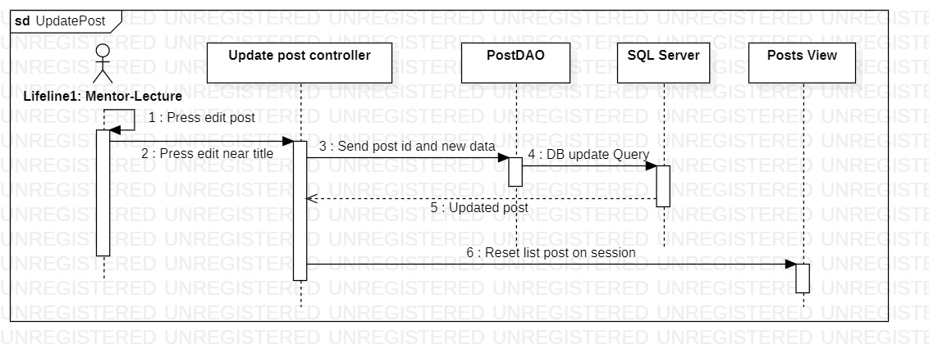

### c. Database queries

userID = User’s id stored in HttpSession

postID = changed post’s id

- Update selected post’s changes to database

*UPDATE tblPosts*

*SET title =?, content =?, video =?, createDate =?,*

*statusId = (SELECT statusId FROM tblStatusPost WHERE statusName=?)*

*WHERE postId =* postID *AND userId=* userID

## 24. Upload File

### a. Class Diagram

### b. Sequence Diagram(s)

*No sequence diagram for this feature.*

### c. Database queries

*No query for this feature*